Student Name: __________________
Class and Section __________________
Total Points (20 pts) __________________
Due: April 12, 2010 before the class

Project: Graph Visualization Learning Tool

CSCI 2410 Data Structures and Algorithms
Armstrong Atlantic State University

Problem Description:

Develop an applet as shown in the following figure.

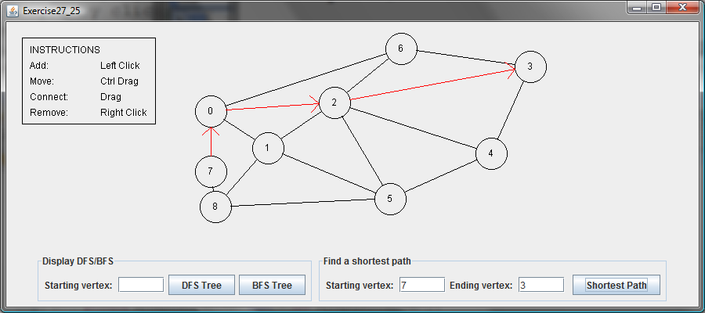

Requirements:
(1) The radius of each vertex is 20 pixels.
(2) The user clicks the left-mouse button to place a vertex centered at the mouse point provided that the mouse point is not inside or too close to an existing vertex.
(3) The user clicks the right-mouse button inside an existing vertex to remove the vertex.
(4) The user presses a mouse button inside a vertex and drags to another vertex and then releases the button to create an edge.
(5) The user drags a vertex while pressing the CTRL key to move a vertex.
(6) The vertices are numbers starting from 0. When a vertex is removed, the vertices are renumbered.
(7) You can click the DFS or BFS button to display a DFS or BFS tree from a starting vertex.
(8) You can click the Shortest Path button to display the shortest path between the two specified vertices.

What to submit?

1. Compile and Submit to LiveLab (you must submit the program regardless whether it complete or incomplete, correct or incorrect)

2. Fill in self-evaluation:

- Can your program display the GUI? _______________
- Can your program create vertices? _______________
- Can your program connect vertices? _______________
- Can your program remove vertices? _______________
- Can your program move vertices? _______________
- Can your program display DFS? _______________
- Can your program display BFS? _______________
- Can your program display a shortest path? _______________
- Can your program display arrowed lines correctly? _______________

